**A Case Study of the Neath River in Wales**

This section presents a comparative analysis of water quality parameter variations measured at upstream, midstream, and downstream stations along the Neath River in Wales from 2000 to 2023, as illustrated in Figure 1. The selected stations for this analysis are (These stations are marked with red boxes in Figure 1.):

Upstream Station (S10003): GWRELYCH ABV NEATH PONT WALBY (station_type: FRESHWATER - UNSPECIFIED)

Nearby MINEWATER Station (S78396): NEW ABERPERGWM COLLIERY SUR' WATER DIS (station_type: MINEWATER)

Midstream Station (S10004): NEATH 500M BELOW ABERDULAIS GS (station_type: FRESHWATER - UNSPECIFIED)

Downstream Station (S78410): NEATH ESTUARY OPP JETTY (station_type: SALINE WATER - ESTUARINE SITES - NON BATHING/SHELLFISH)

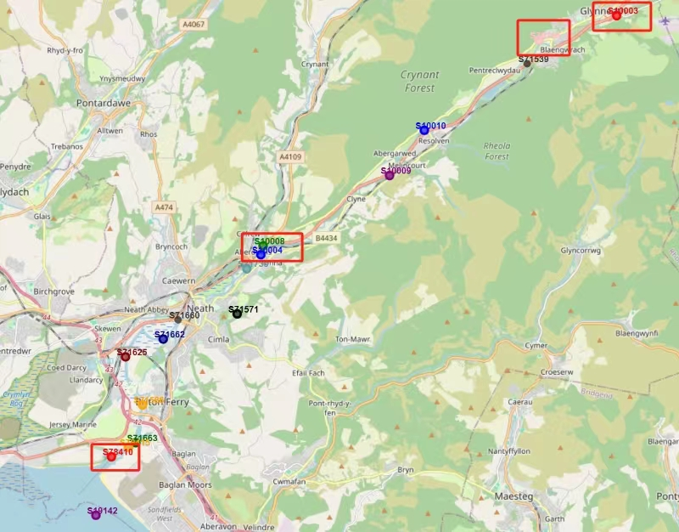

Figure 1: Neath River in Wales

Seventeen parameters were selected for analysis along the Neath River, focusing on comparing upstream, midstream, downstream, and a MINEWATER station. Among these parameters, dissolved oxygen saturation percentage (Oxygen, Dissolved, % Saturation) is highlighted due to its significance in assessing water quality.

**Dissolved Oxygen Saturation Percentage (Oxygen, Dissolved, % Saturation):**

Standard for Healthy Freshwater: For healthy freshwater lakes and rivers, dissolved oxygen saturation is generally expected to remain at least between 60% and 80% according to the U.S. Environmental Protection Agency (EPA, 1986) and the World Health Organization (WHO, 2003).

Observations Across Stations: Except for the MINEWATER station, all other stations consistently recorded dissolved oxygen saturation levels above 80%, indicating healthy aquatic conditions. In contrast, the MINEWATER station exhibited comparatively lower saturation levels.

Trends Across Stations: The trend of dissolved oxygen saturation at the MINEWATER station significantly overlaps with other stations, suggesting similar ecological influences despite its lower values (see Figure 2 & 3).

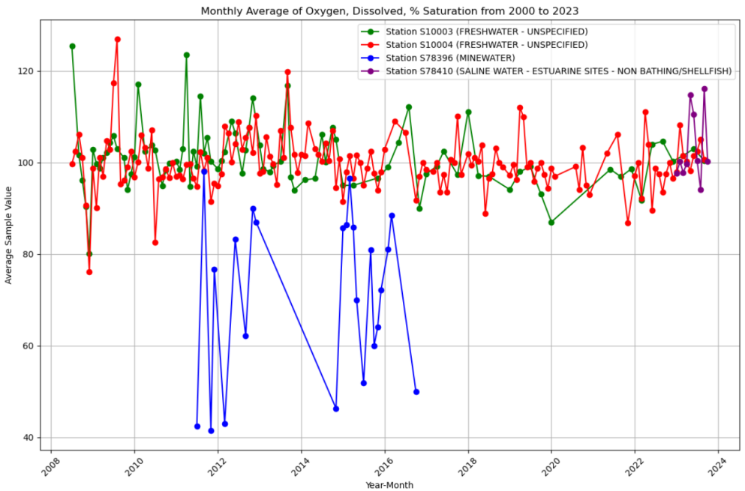

Figure 2: Monthly Average of Oxygen, Dissolved % Saturation from 2000 to 2023

**Temperature Trends:**

Temperature Variations: Similarly, the trend of water temperature changes also shows a high degree of overlap among all stations (see Figure 4). According to the European Water Framework Directive (WFD, 2000), water temperature should not deviate significantly from natural conditions to avoid stress on ecosystems.

Implications: The analysis indicates that while general water quality parameters like temperature show uniform trends across the river, specific indicators such as dissolved oxygen saturation exhibit variations due to potential influences from MINEWATER discharges. These findings underscore the importance of monitoring industrial impacts on river ecosystems and maintaining critical ecological balances.

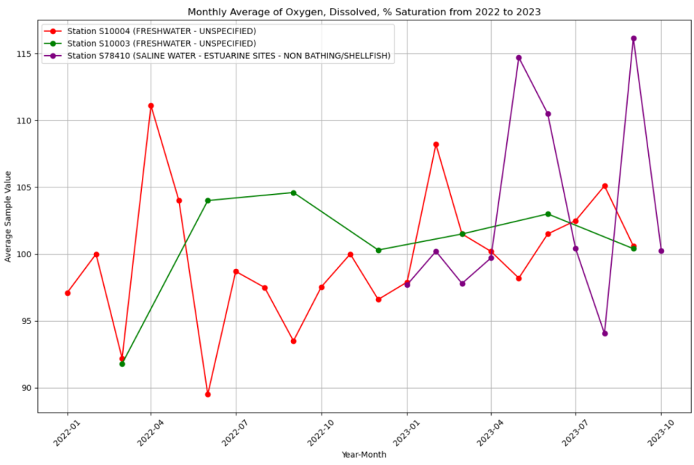

Figure 3: Monthly Average of Oxygen, Dissolved, % Saturation from 2022 to 2023

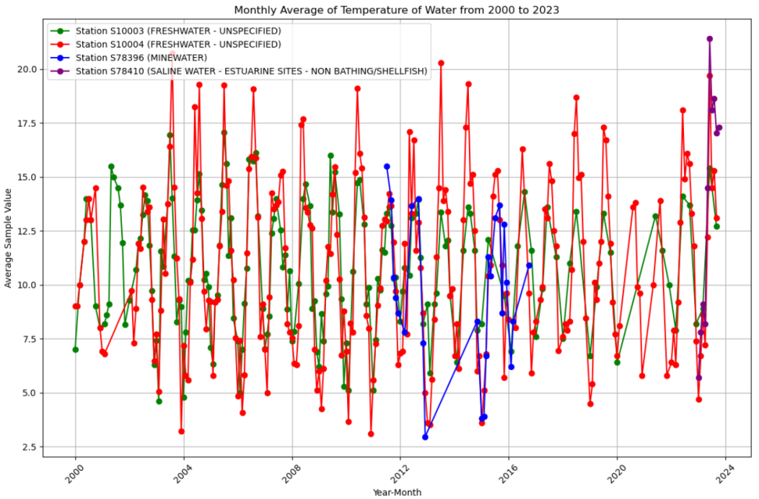

Figure 4: Monthly Average of Temperature from 2022 to 2023

**Sodium, Dissolved (mg/L):**

Sodium concentration in drinking water is typically regulated according to the UK Drinking Water Quality Standards, which generally set the maximum permissible limit at 200 mg/L (UK Drinking Water Inspectorate, 2020). However, for water bodies used in ecological monitoring, sodium concentration standards may be more lenient.

Observations Across Stations: Sodium levels at the MINEWATER station were consistently higher compared to both its upstream and downstream stations. Notably, the upstream station exhibited the same variation trends as the MINEWATER station, suggesting possible influences from mining activities (see Figure 5 & 6).

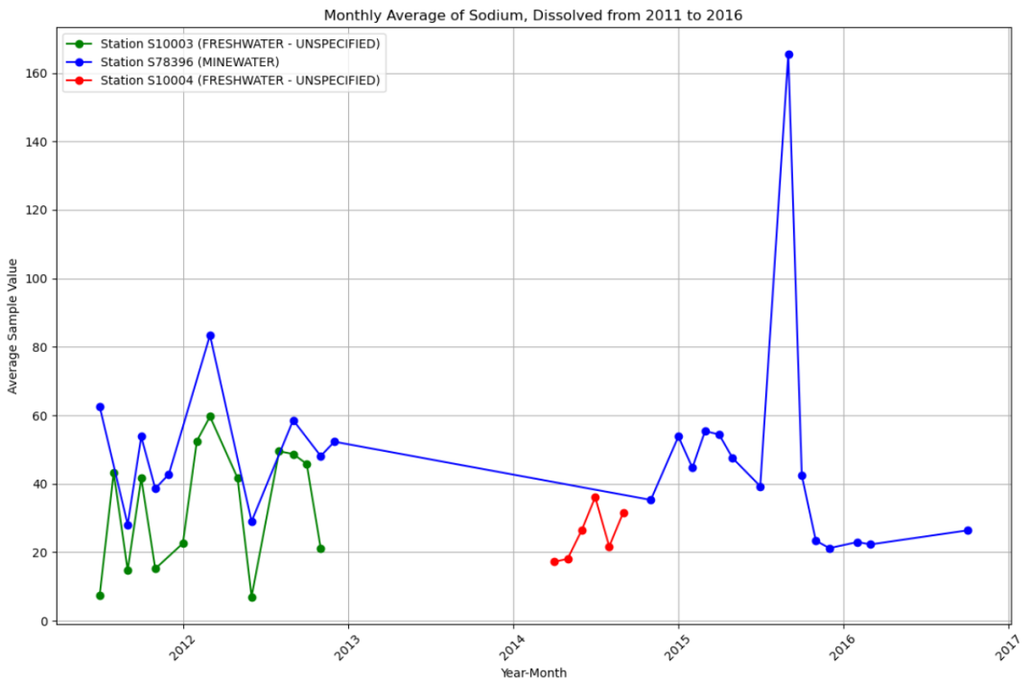

Figure 5: Monthly Average of Sodium, Dissolved from 2011 to 2016 (mg/l)

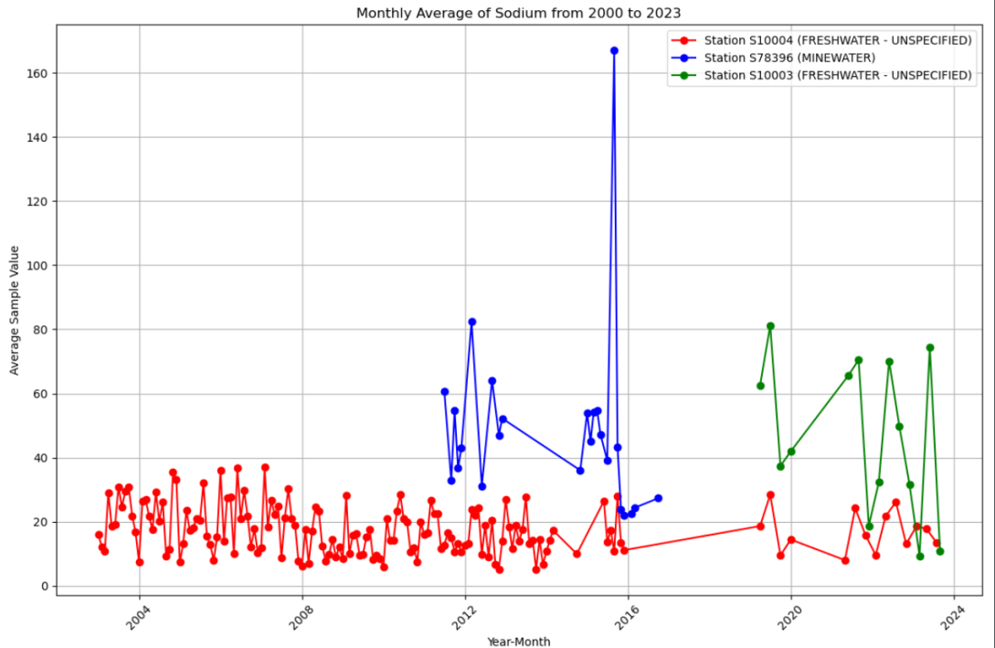

Figure 6: Monthly Average of Sodium from 2000 to 2023 (mg/l)

**pH: In Situ:**

On-site pH measurements at the MINEWATER station consistently exhibited weaker alkalinity compared to other stations along the Neath River (Figure 7). Specifically, the upstream station showed the strongest alkalinity, with pH values fluctuating between 8.1 and 8.75. In contrast, the midstream station's pH ranged between 7.5 and 8.5, reflecting slightly more varied conditions. These observations suggest differential impacts on water chemistry potentially related to varying environmental and anthropogenic influences along the river.

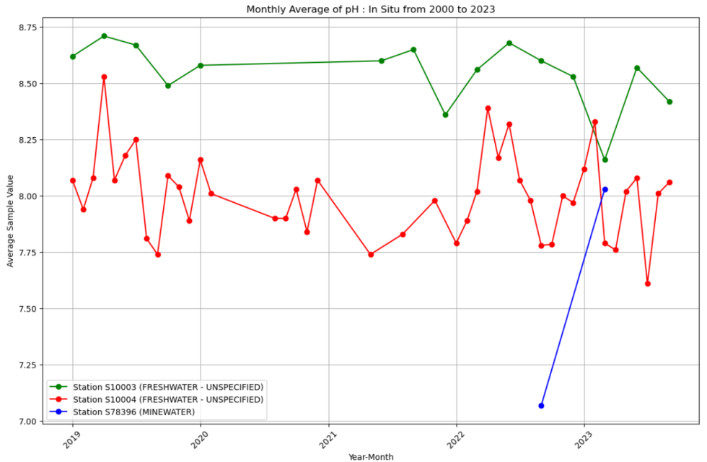

Figure 7: Monthly Average of pH: In Situ from 2000 to 2023

**pH:**

The pH fluctuations at the MINEWATER station appear to influence the downstream midstream station-S10004 (Figure 8 & 9), with both sites exhibiting similar trends in their pH changes. It is notable that the alkalinity at the MINEWATER station is weaker compared to other stations along the river. This correlation suggests that discharges or runoff from the MINEWATER site may have a discernible impact on the water chemistry at subsequent downstream locations, highlighting the interconnectedness of riverine systems and the potential for upstream activities to affect downstream water quality.

**Sulphate as SO4 (mg/L):**

In the context of river ecosystems in the UK, sulphate concentrations typically do not have a strict upper limit unless there is specific pollution linked to activities such as mining or industrial discharges. The Environment Agency considers sulphate levels below 400 mg/L to generally be within acceptable ranges for maintaining river health (UK Environment Agency, 2015). In the case of the Neath River, all stations reported sulphate levels below 200 mg/L (Figure 10), well within the safe range for both aquatic life and general water quality standards(Water Framework Directive, 2000).

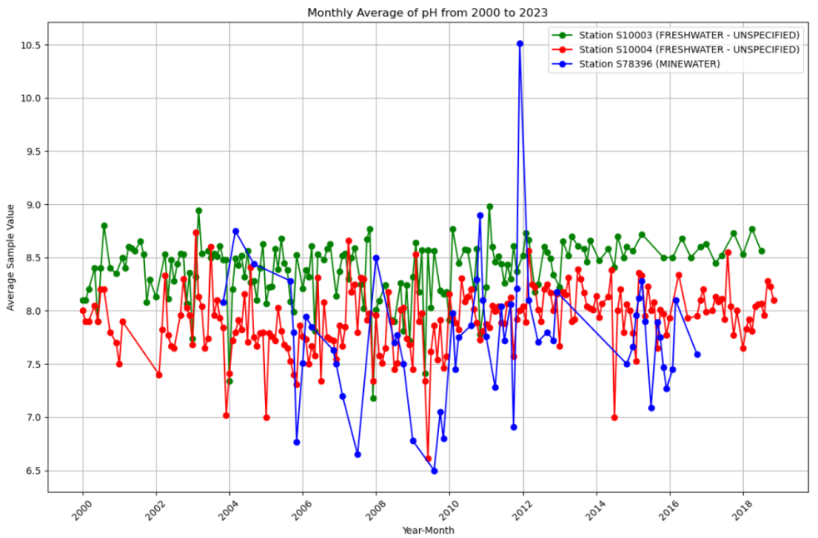

Figure 8: Monthly Average of pH from 2000 to 2023

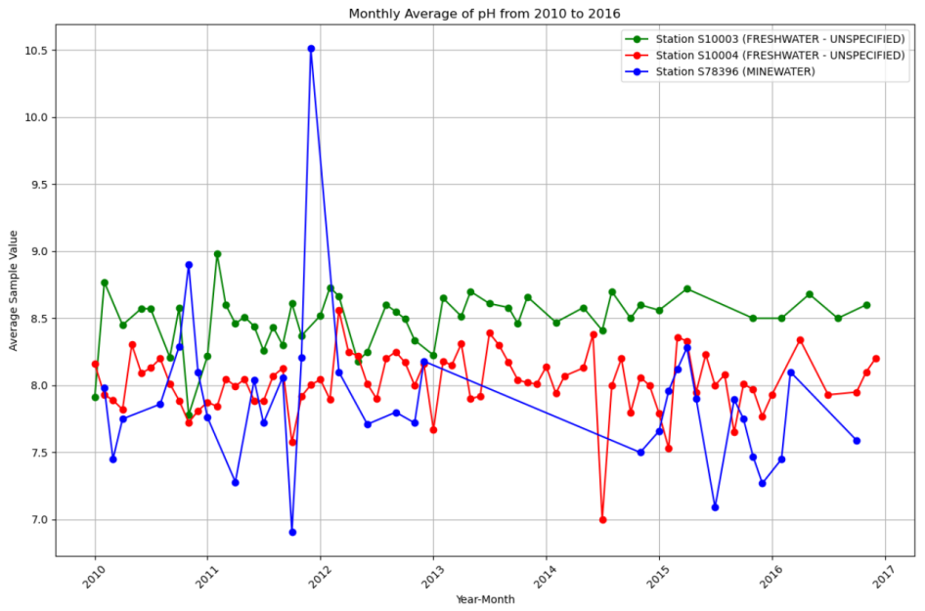

Figure 9: Monthly Average of pH from 2010 to 2016

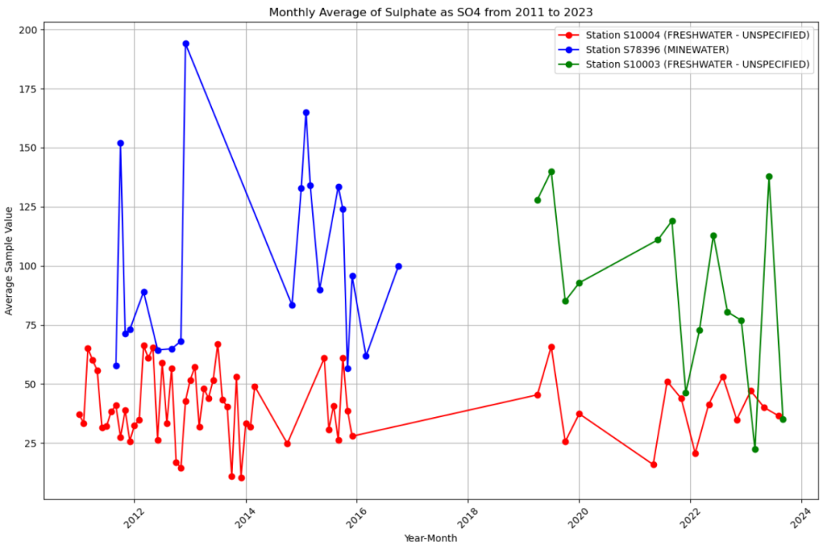

Figure 10: Monthly Average of Sulphate as SO4 from 2000 to 2023 (mg/l)

The calcium concentration at the MINEWATER station is consistently higher compared to the downstream station (Figure 11), S10004. Additionally, the calcium levels at S10004 tend to increase in tandem with the rise in calcium concentrations at the MINEWATER station (S78396) (Figure 12). This suggests a potential influence of MINEWATER discharge on the calcium levels at downstream stations, indicating a possible transfer of dissolved minerals through water flow.

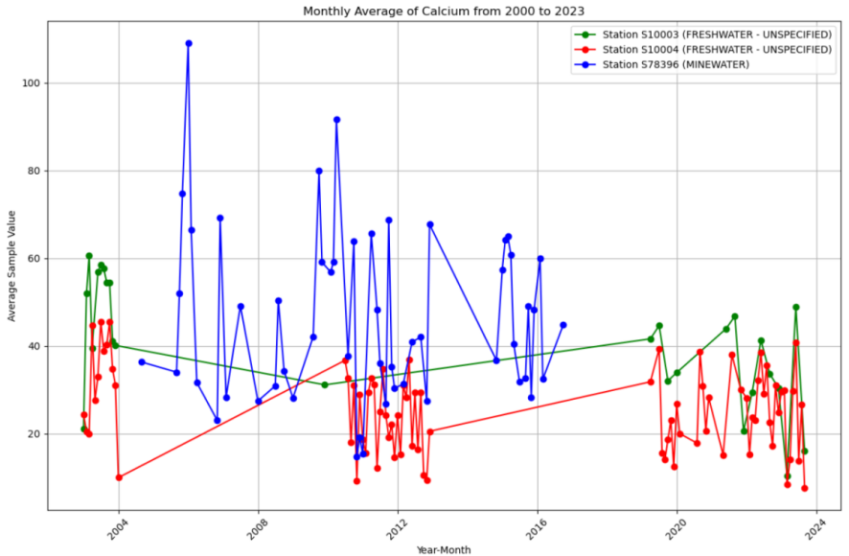

Figure 11: Monthly Average of Calcium from 2000 to 2023 (mg/l)

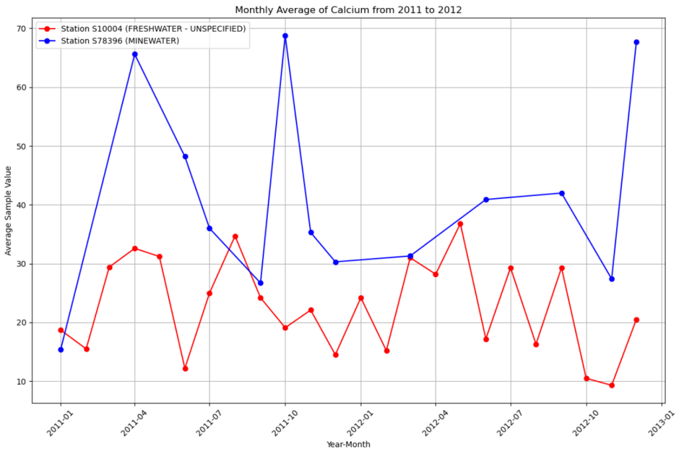

Figure 12: Monthly Average of Calcium from 2011 to 2012 (mg/l)

**Calcium, Dissolved (Figure 13)**

Due to significant gaps in the data across the years, no clear trend can be observed for the dissolved calcium concentrations at the three monitoring stations (S10003, S10004, and S78396). The missing data limits the ability to determine long-term trends or seasonal patterns in calcium levels. The dissolved calcium levels are generally higher at the MINEWATER station (blue line) compared to the other stations, indicating that mining activities may contribute to elevated calcium concentrations. However, based on the available data, it appears that calcium levels fluctuate without a consistent trend, making it difficult to draw definitive conclusions regarding the influence of the MINEWATER station on downstream stations. Further data collection and analysis are necessary to establish any potential correlations.

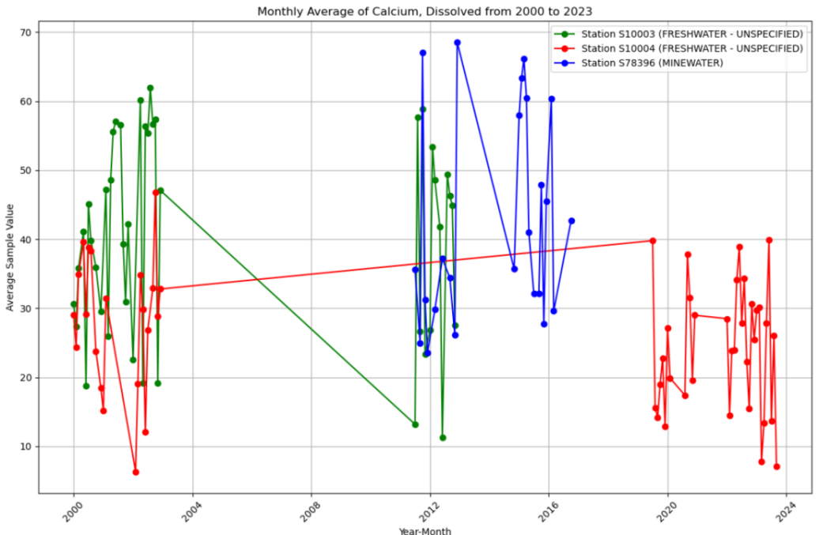

Figure 13: Monthly Average of Calcium, Dissolved from 2000 to 2023 (mg/l)

**Solids, Suspended at 105°C (Figure 14):**

The concentration of suspended solids at the MINEWATER station is consistently higher than at the other monitoring stations. This suggests that the MINEWATER site may be contributing higher levels of suspended solids, potentially due to mining activities or related disturbances in the area.

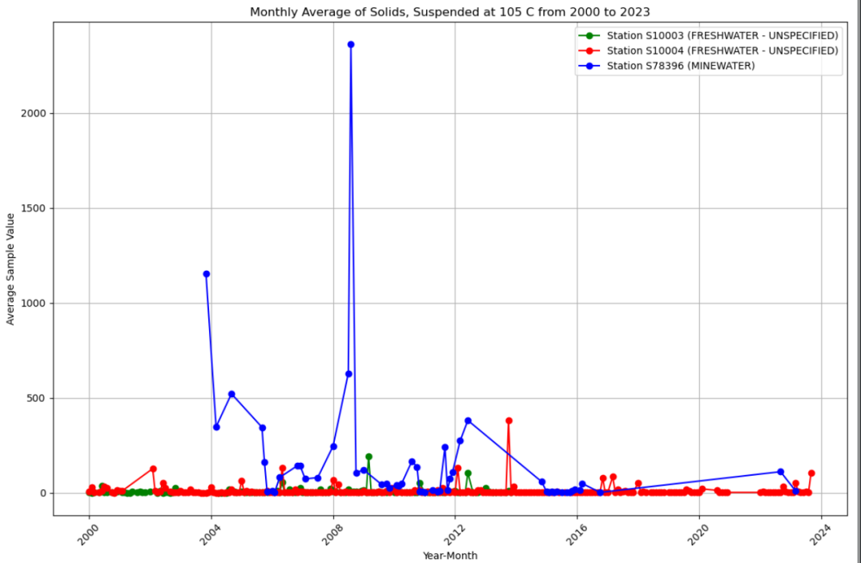

Figure 14: Monthly Average of Solids, Suspended at 105°C from 2000 to 2023

**Magnesium (Mg)-Figure 15 & 16:**

In natural water bodies, magnesium concentrations typically range between 10 and 100 mg/L (WHO, 2017; Water Framework Directive, 2000). The magnesium levels measured at the selected stations (S10003, S78396, and S10004) all fall within this standard range, indicating that the water quality is within acceptable limits for this parameter.

The magnesium concentration at the upstream station (S10003) is consistently higher compared to both the MINEWATER station (S78396) and the midstream station (S10004). This may reflect natural variations in the geology and sources of water contributing to the upstream area.

The magnesium levels at the MINEWATER station (S78396) exhibit a trend that closely aligns with the variations observed at the midstream station (S10004). This indicates that magnesium levels downstream of the MINEWATER site are potentially influenced by both the natural conditions and the mining activities at the site.

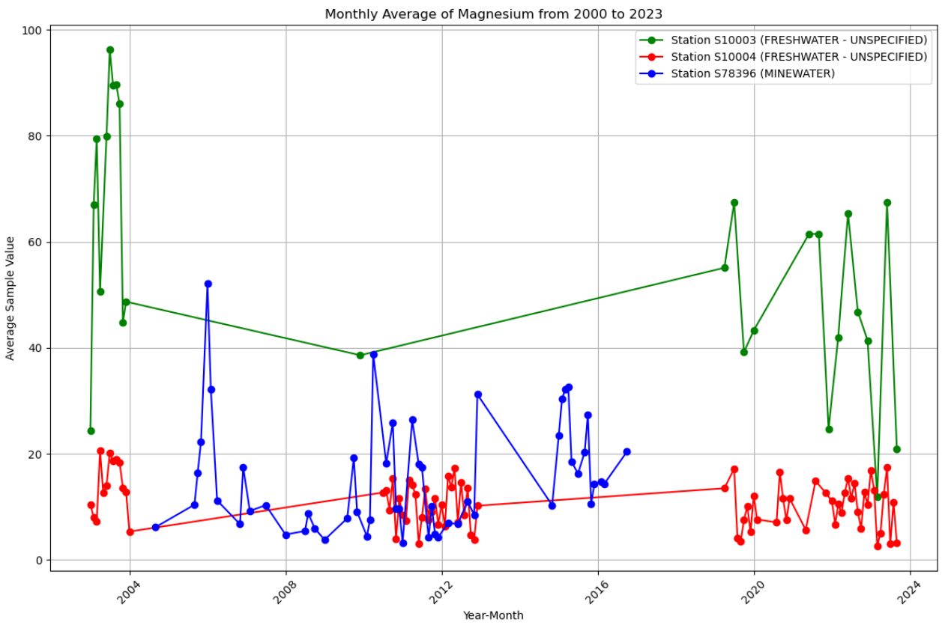

Figure 15: Monthly Average of Magnesium from 2000 to 2023 (mg/l)

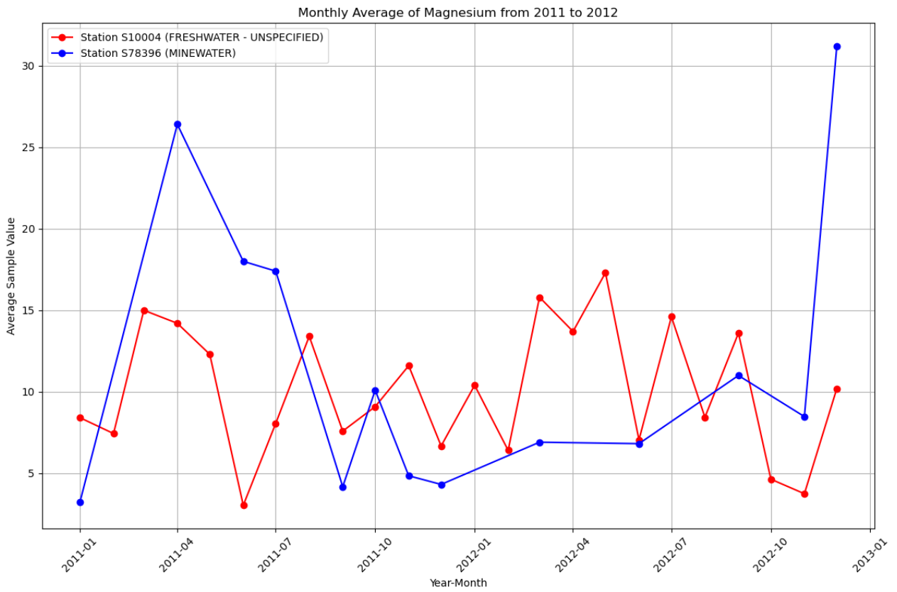

Figure 16: Monthly Average of Magnesium from 2011 to 2012 (mg/l)

**Iron, Dissolved - Figure 17:**

The dissolved iron content at the MINEWATER station (S78396) is comparatively low. This observation could suggest effective management or treatment of iron discharges from mining activities, or geological factors that naturally limit iron dissolution into the water. Contrarily, the iron levels at station S10004, located downstream, are relatively high. This elevation could be influenced by sediment resuspension, runoff from surrounding lands, or other industrial inputs further downstream.

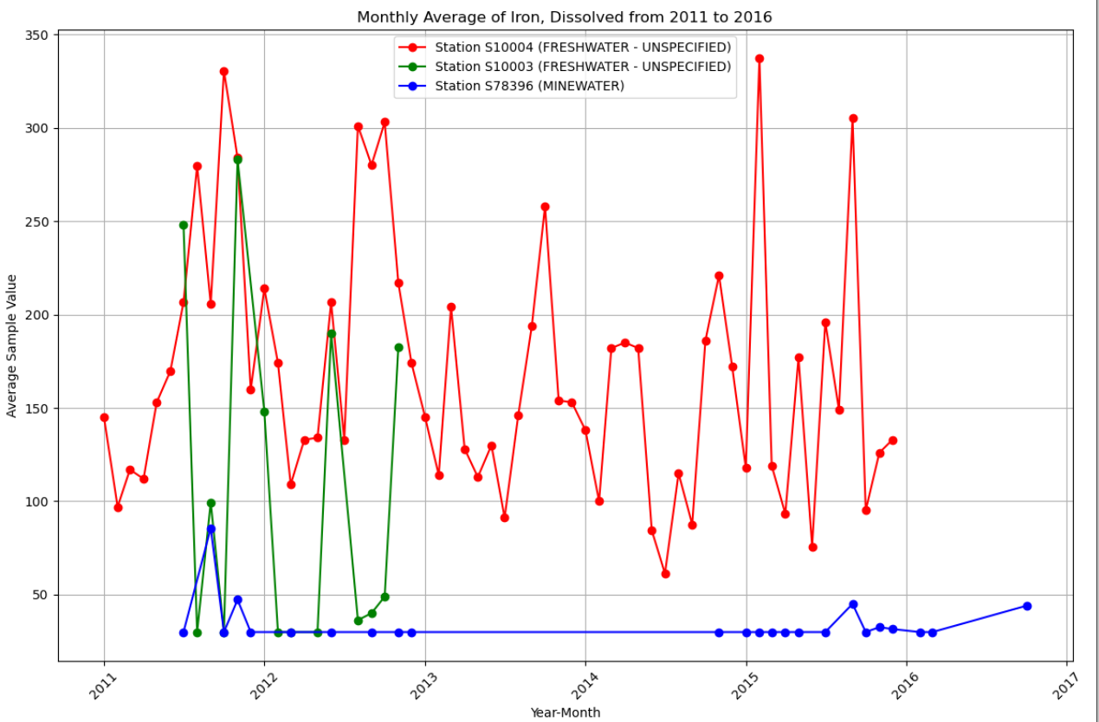

Figure 17: Monthly Average of Iron, Dissolved from 2011 to 2016 (ug/l)

Sodium, Conductivity at 25°C, Potassium, Dissolved, and Temperature of Water Trends:

The trend charts for Sodium, Conductivity at 25°C, Potassium, Dissolved, and Water Temperature can be found in Appendix 6.

Based on the analysis of water quality in the Neath River, it can be inferred that changes in parameter values at upstream stations may influence the values observed at downstream stations. The MINEWATER station, located near the river, often exhibits relatively high measurements for some parameters. However, these elevated measurements can also affect the parameter values at downstream stations, indicating a downstream impact. Similarly, the MINEWATER station is influenced by the parameter measurements from the upstream stations, showing an interconnected dynamic where upstream conditions propagate downstream.

* + 1. A Case Study of the Afan River in Wales

This section presents a comparative analysis of water quality parameter changes at upstream, midstream, and downstream stations along the Afan River in Wales, from 2000 to 2023 (All visualizations and trend charts for the measured parameters can be found in Appendix 6.):

**Upstream Station:**

**Station Number: S11004 (Green mark in Figure 4.31)**

Station Name: R PELENA -R.B ABOVE AFAN CONF. (Pelenna River upstream of the Afan River confluence)

Station Type: FRESHWATER - UNSPECIFIED

**Midstream Station:**

**Station Number: S71002 (Blue mark in Figure 4.31)**

Station Name: R.AFAN AT NEWBRIDGE ROAD, PORT TALBOT (Afan River at Newbridge Road, Port Talbot)

Station Type: SALINE WATER - COASTAL SITES - NON BATHING/SHELLFISH

**Downstream Station:**

**Station Number: S74109**

Station Name: AFAN O/F: 100M DOWNTIDE (Afan River Outfall: 100m Downstream)

Station Type: SALINE WATER - COASTAL SITES - NON BATHING/SHELLFISH 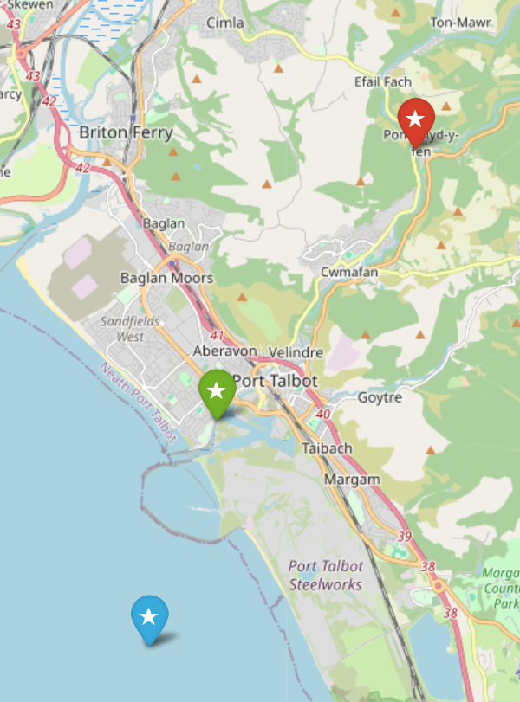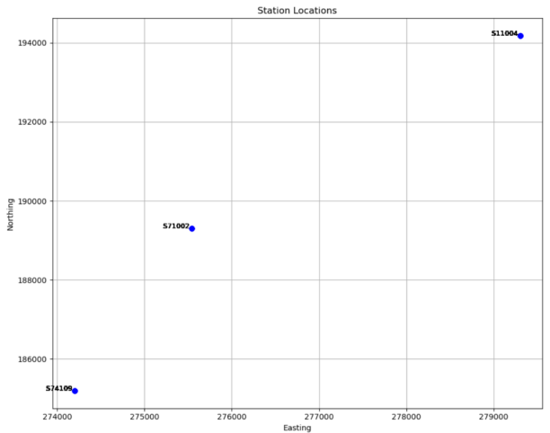

Figure 4.31: Afan River on map Figure 4.32: Afan River-Plane coordinates

**Common Measured Parameters Across Upstream, Midstream, and Downstream Stations:**

**Solids, Suspended at 105°C:**

This parameter is consistent across all three stations and reflects the concentration of suspended particles. Variations could indicate sediment or particulate matter influences from upstream or anthropogenic sources, but all stations share similar trends over time.

**Temperature of Water:**

Water temperature fluctuates with the seasons, showing similar trends across the upstream, midstream, and downstream stations. Seasonal changes lead to consistent temperature variations at all sites, likely due to shared regional climatic conditions.

**Oxygen, Dissolved, % Saturation:**

The dissolved oxygen saturation shows a similar trend across all stations. However, downstream dissolved oxygen levels are often lower compared to upstream levels, potentially due to organic material and urban runoff reducing oxygen availability in downstream waters.

**Common Measured Parameters Between Upstream and Downstream Stations:**

**Copper, Dissolved:**

Copper levels are significantly higher upstream. When copper levels increase upstream, a corresponding increase is observed downstream, and likewise, decreases upstream result in lower downstream levels.

**Calcium:**

Calcium levels are markedly higher downstream compared to upstream, indicating possible influences from saline intrusion or sedimentary processes near the river’s mouth.

**Solids, Suspended at 105°C:**

As seen across all stations, suspended solids remain a common measure between upstream and downstream stations, with variations potentially influenced by runoff, sediment transport, or human activities.

**Magnesium:**

Magnesium concentrations downstream are considerably higher than those upstream, reflecting typical magnesium concentrations in natural water bodies (0.5 to 150 mg/L). The downstream station (S74109) shows unusually high magnesium levels.

**pH : In Situ:**

The downstream station (S74109) has only one recorded pH value of 8, whereas the upstream station (S11004) shows a range between 7.24 and 8.01, indicating that upstream waters are closer to neutral, while downstream waters are more alkaline.

**pH:**

The pH values show similar trends in upstream and downstream waters, with downstream water being more alkaline than upstream, which remains closer to neutral.

**Carbon, Organic, Dissolved as C (DOC):**

Dissolved organic carbon levels tend to be higher upstream. The concentration of dissolved organic carbon in upstream waters also affects the downstream levels, indicating the transport of organic material along the river's flow.

**Iron, Dissolved:**

The dissolved iron concentration is higher upstream, with significant fluctuations. In contrast, downstream iron levels are relatively low and stable, showing minimal variation.

**Oxygen, Dissolved, % Saturation:**

As mentioned earlier, both upstream and downstream stations exhibit similar dissolved oxygen trends, though downstream levels are often slightly lower than those upstream, likely due to increased organic matter or anthropogenic influences affecting oxygen levels.